**Capstone Project:**

**Tourist Map for Hamburg**

By Max Emanuel Feucht

**Introduction / Business Problem**

When visiting a new city, most people use some kind of tourist guide; Be it a guidebook, websites like Tripadvisor, or a person that is already familiar with the city. Means like these help with orienting in a city based on experience from others, which poses a good starting point for discovering a city on one’s own. However, vibrant metropols are characterized by constant change in many domains of public life: Bars, Clubs, Restaurants, Cafés and many more localities are opening and closing with a rapid frequency. Along with this (and possibly caused by this), city districts continously change their appearance, their character, and the target audience they attract. To keep track of a city’s transformation, an up-to-date overview over localities in a citys districts would be helpful, allowing tourists to specifically target those areas that fulfill their wishes regarding gastronomic establishments. Websites like Tripadvisor offer an overview over different locations of establishments in the form of city maps, however requiring to look at every single establishment to check, whether the respective establishment is a café, a bar, a restaurant, etc. The sheer amount of information on sites like Tripadvisor might further be overwhelming, leaving tourists wishing for a quick overview over district characteristics reagarding the number and / or density of establishments from various categories located there. In order to easen the process of getting such an overview, a map covering all that information would come in handy for many tourists. Along with the information about the density of establishments from various categories, the density of inhabitants might be of interest in such a context as well; Some “business districts” might have many restaurants and takeaways, which might be located there mainly to provide nearby businesses with lunch opportunities. Such districts would probably not be of interest for most tourists. Contrary to that, “scene districts” showing the same amount of establishments but a much higher population denisty are likely to satisfy many tourists in their search for amusement and consumption. The population density therefore seems to serve as a appropriate variable to enrich the information of establishment density to ultimately provide an accurate and precise guidance for tourists. To allow getting a real quick impression over the characteristic of a district, the single districts of a city are further clustered and assigned to categories, depending on the density of establishments of various categories and the density of inhabitants.

Creating such a helpful, easy-to-use and up-to-date map for tourists could be of great value for stakeholders like tourist websites such as Tripadvisor and Yelp, or online Guidebooks such as “marcopolo”, targeting especially gastronomy-oriented and tech-affine tourists. The creation of the proposed map is the goal of the Capstone project at hand. This approach is tested for the city of Hamburg, as it is the second largest city in Germany, shows a wide variety in districts and happens to be my beautiful hometown.

**Data**

The project at hand specifically focuses on the characteristics of city districts. I therefore looked for socioeconomic data for city districts as well as the corresponding Geodata. The socioeconomic profile of city districts was obtained from:

[https://www.statistik-nord.de/zahlen-fakten/regionalstatistik-datenbanken-und-karten/hamburger-stadtteil-profile-staedtestatistik-fuer-hamburg](https://www.statistik-nord.de/zahlen-fakten/regionalstatistik-datenbanken-und-karten/hamburger-stadtteil-profile-staedtestatistik-fuer-hamburg%22)

From this source, I used the district names, their area size, the inhabitant number and economic data such as price per sqaure meter for a flat. Those economic variables were later dropped from the analysis beacaus of the high missing rates.

The Geodata could be obtained by ESRI Germany’s API:

<https://opendata-esri-de.opendata.arcgis.com/datasets/8437e52c5e2d4963b6098accf571a891_0/geoservice?geometry=7.392%2C53.395%2C11.347%2C53.965>

This API delivers a simple GeoJSON file for all city districts of Hamburg containing information about the districts name as well as the polygon shape of the respective districts in World Geodetic System 1984 (WGS84) coordinates.

Further, the establishment data was retrieved from the Foursquare API. With the data within the GeoJSON file mentioned before, I computed the center coordinates for each district, to obtain the coordinates to pass into the Foursquare API for establishment retrieval. I used a search request and passed those coordinates as well as a limit of 1000 establishments per neighborhood in. The radius to search in was determined by the area size of each Neighborhood. For further details, see the Methodology section. The variables used from the Foursquare API were the venue names, the venue category, as well as the latitude and longitude of each venue. All of this information was stored in a dataframe along with the name and coordinates of the neighborhood whose coordinated were used to make the search request. Specifically, the dataframe from the API retrieval looked like this:

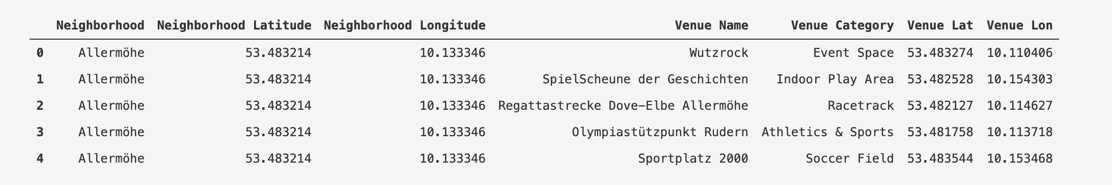

**Methodology**

The radius was computed by dividing the area size of each district by Pi and then taking the sqaureroot of the result. This yielded an approximate radius which covered the area that was given in the fist source. As not every district is nearly circle-shaped, this approach is only an approximation; especially very long or very thin districts might therefore be underrepresented in the given analysis. Given that the resulting circles might overlap and some of the uncovered areas might by covered by nearby retrieval radii, this is mostly a problem concerning the border districts. To account for this, I calculated the distance of each Neighborhood center to the city center coordinates. When the distance was below 5 km and districts I added only 10% to the retrieval radius. If the distance was over 5km an, I added 40% to the radius, to account for the wider and less densely arranged city districts. A depicition of areas covered with this approach is given below; on the left side, you see the coverage with the unaltered radii, on the right you see the adapted radii.

As a result, some of the single radii overlapped, which is why some restaurants were retrieved for two districts. To determine to which district the respective establishment belongs, the distance to the district centers by which the establishment was retrieved was calculated. When an establishment was listed twice or more, only the entry with the smallest distance was kept, and the establishment was assigned to the neighborhood that was closest by.

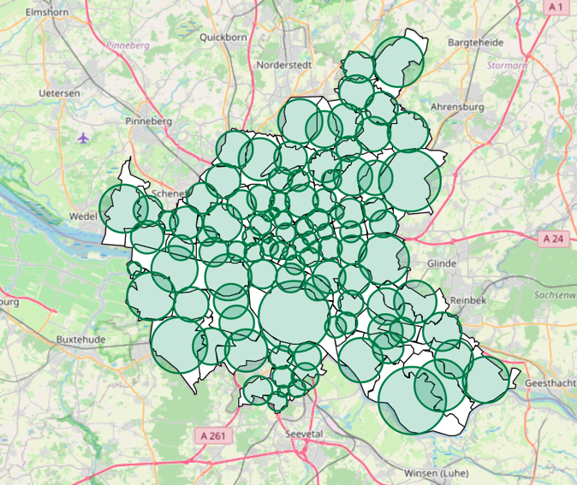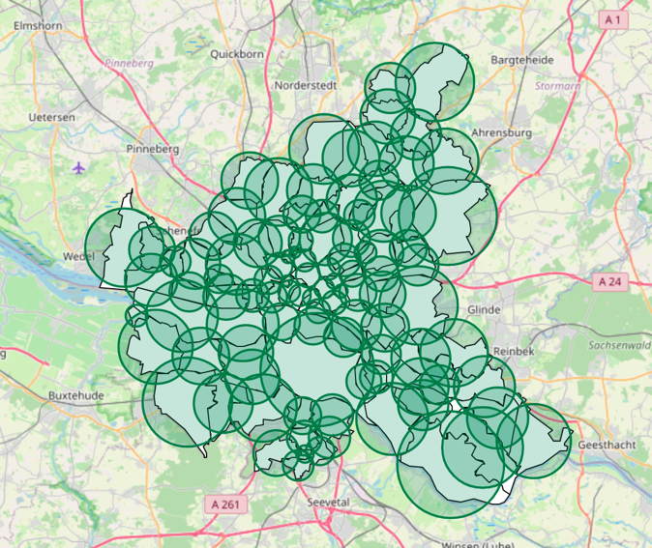

To keep later clustering comprehensive and to narrow the map down to gastronomic information, only those venues were selected, that could be assigned to one gastronomic category; Restaurants, Bars, Cafés, To Go establishments and Clubs. If a venue category contained a keyword for one of these categories (e.g., Japanese Restaurant with keyword Restaurant), it was assigned to this category. The full list of keywords with corresponding category is given below. The keywords were chosen based on existing Foursquare categories. Some venue categories contained keywords from two categories (e.g., Falafel Restaurant); after closer investigation, it became apparent that this were all To Go establishments that contained the word "Restaurant" nonetheless. All of these cases were then manually classified as To Go establishment only. After this procedure, each venue was assigned to exactely one category. This approach will be referred to as the One-Class approach in the discussion.

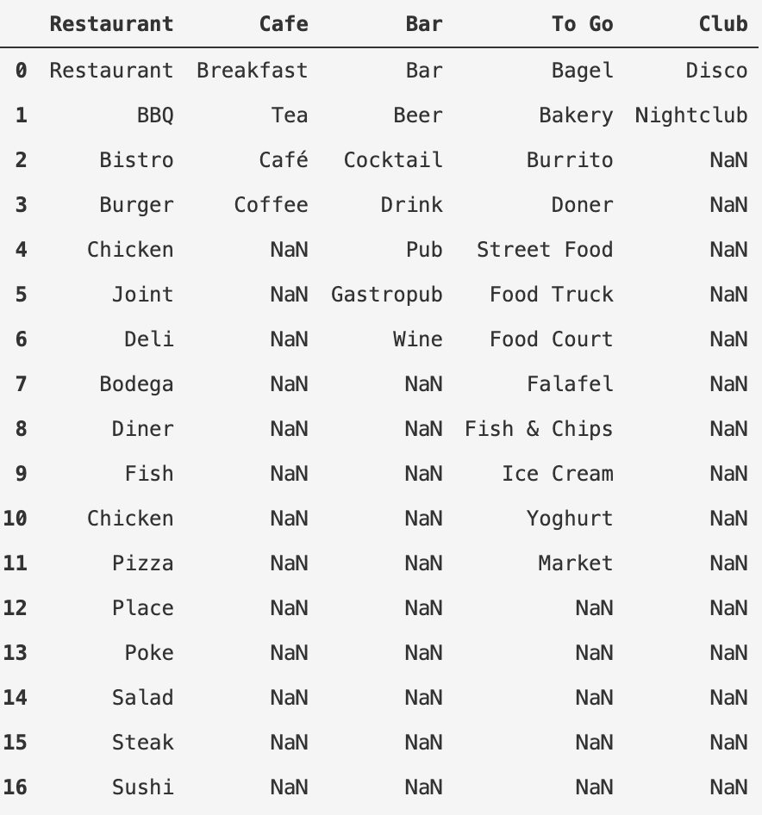

Class assignment was done by dummy-coding: I created 5 columns, one for each category and set them to 0 by default. If an establishment contained the word “Restaurant”, it was assigned the value 1 in the Restaurant column. With this approach, it was possible to sum up the single entries to get information about the establishment distribution across districts.

The final gastronomic dataframe consisted of 1467 establishments distributed over Hamburg. The dataframe was further grouped by Neighborhoods and the dummy-coded columns were summed by group. With this approach, a dataframe with one row for each district and one column for each category was created and each cell containing the number of establishments for the respective category and the respecrtive district. Below you can have a look at how gastronomic categories were distributed across Neighborhoods:

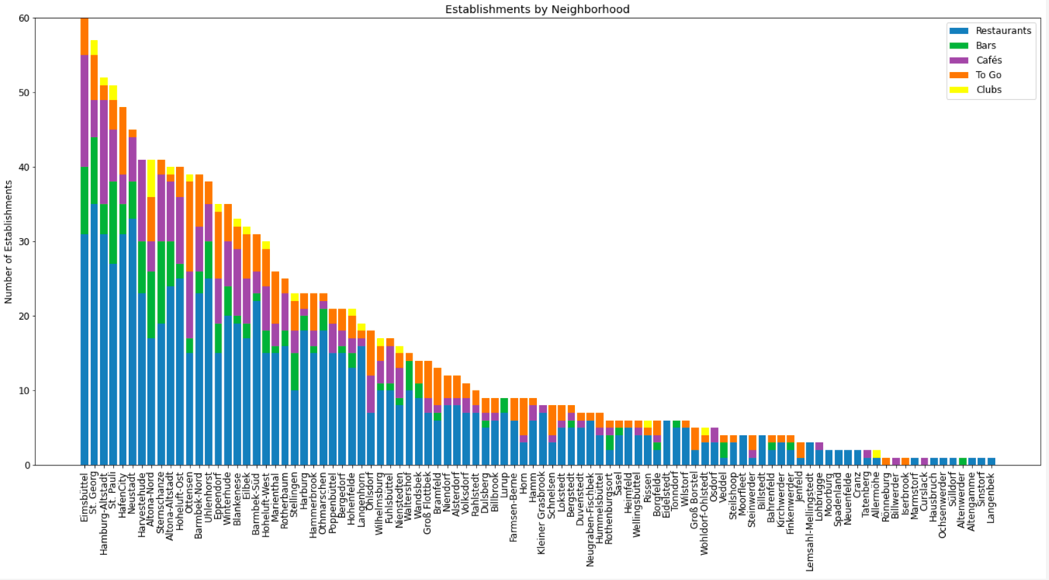

Eimsbüttel (60), St. Georg (57), Hamburg-Altstadt (52), St. Pauli (51) and the Hafencity (48) show the most establishments, while districts like Iserbrook or Ochsenwerder appear last with only 1 establishment each. It is further apparent, that restaurants make up the largest part of establishments (depicted in blue in the barchart above).

Next, the data was prepared for Clustering. As we are not only interested in the mere number of establishments per district due to the large diversity in district area sizes, the establishment density was computed for each neighborhood. This was done by dividing the number of establishments per category per district by the area size of the respective district. The resulting densities for each category were then taken as features for clusering. Further, the inhabitant density was also selected as a feature for clustering. Clustering was done using a k-means Algorithm. To find the optimal number of clusters (k-value), the Elbow method was applied; using this approach, an optimal k of 5 was determined. To further examine the characteristics of each cluster, the feature dataframe was grouped by cluster labels and the single columns were averaged by clusters.

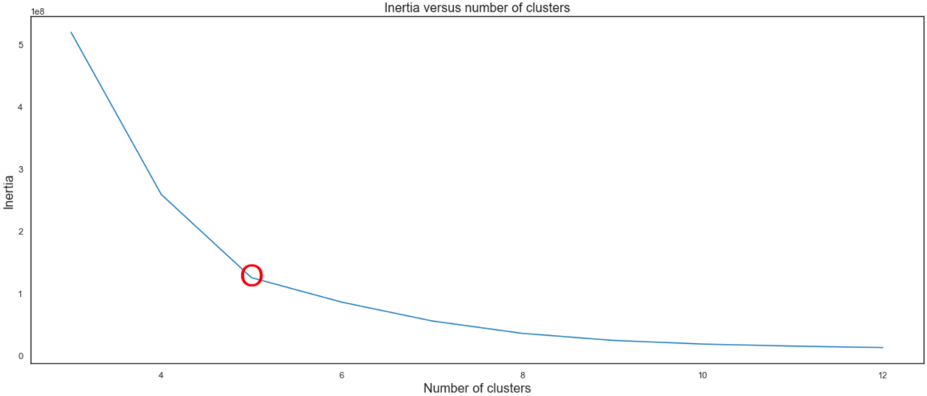

**Results**

The Clustering resulted in 5 clusters, that differed in both establishment density as well as inhabitant density. The mean densities of clusters demonstrate that quite well:

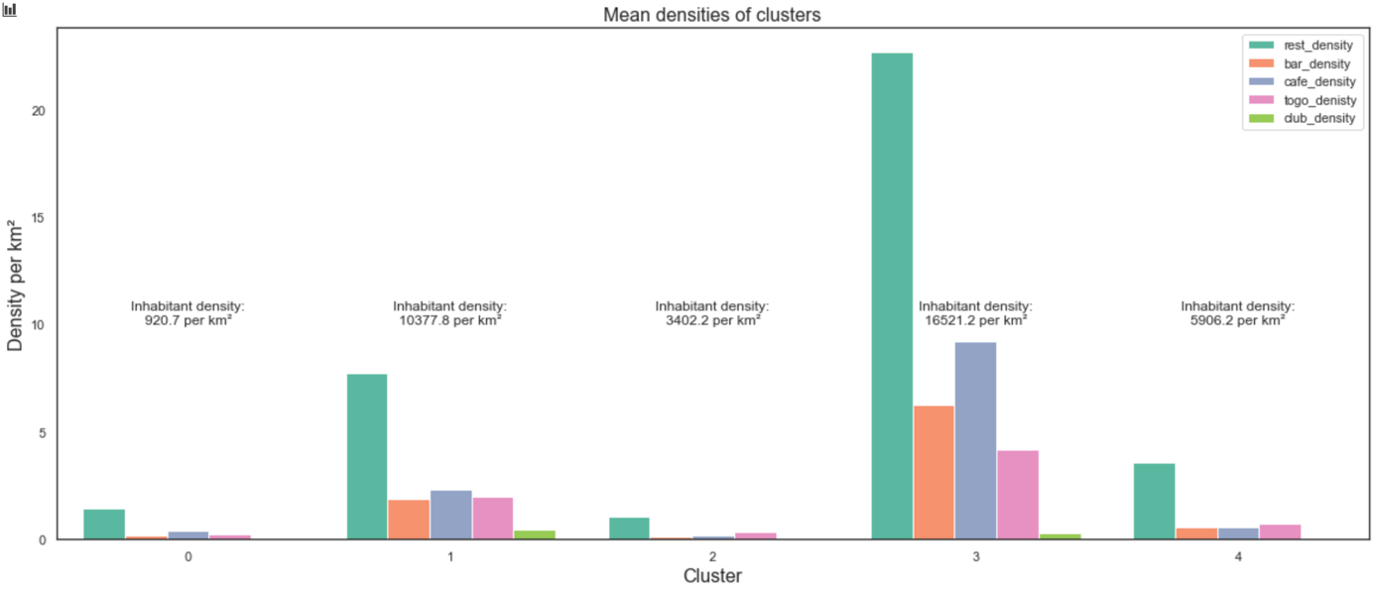

Cluster 0 is characterized by a very sparse population as well as a very sparse establishment density. Some single restaurants may be found in those districts, however this would not be a recommendation to look for gastronomical revelations.

Cluster 1 shows a dense population with an average of over 10000 inhabitants per square kilometer. Next to this, quite various gastronomy is located in those districts, with a large focus on restaurants, but with some opportunities for coffee, beer or some snacks to go. Clubs only rarely appear in those districts.

Cluster 2 is hardly distinguishable from Cluster 1 with regard to establishment density. Nearl no establishment can be expected in those areas. It becomes apparent that Cluster 3 simply shows a higher inhabitant density than Cluster 1, which is still quite low with around 3000 – 4000 inhabitants per square kilometer however.

Cluster 3 is the most protruding Cluster of all – it is characerized by a very high etablishment density, while being highly diverse at the same time. Over 20 restaurants, around 10 cafés, 7 bars and 5 To go establishments can be found here per square kilometer on average. Only clubs seem to be rare in the respective districts. Next to this, the districts show a very large population density with an average of 16.500 inhabitants per square kilometer. Those areas are therefore termed as “populational hotspots” and offer tourists the most who look for a diverese gastronomical landscape.

Cluster 4 is again characterized by rather sparse establishment density, however some restaurants might be found there; when in luck maybe even a bar or a café. These districts might provide some gastronomy for residents but might not be suitable for diverese gastronomical expectations of tourists. The respective districts show an medium population density of nearly 6000 inhabitants per square kilometer.

Now that the single Clusters were characterized, it is now of interest which district belongs to which cluster. This information then further allows validation of the conducted clustering; living in Hamburg for 4.5 years now, I might figure if the clustering makes sense or if districts do not fit the clustered profile from my own experience. The clustering of all hamburg districts is shown in the map below: Cluster names and colors can be obtained from the (draggable) legend. Further, when hovering over one district, the districts name, its inhabitant density, the single establishment densities as well as its assigned Cluster appear in a popup, as shown in the bottom left part of the graphic. It is finally possible to show the single establishment categories on the map by clicking the respective category in the top right box.

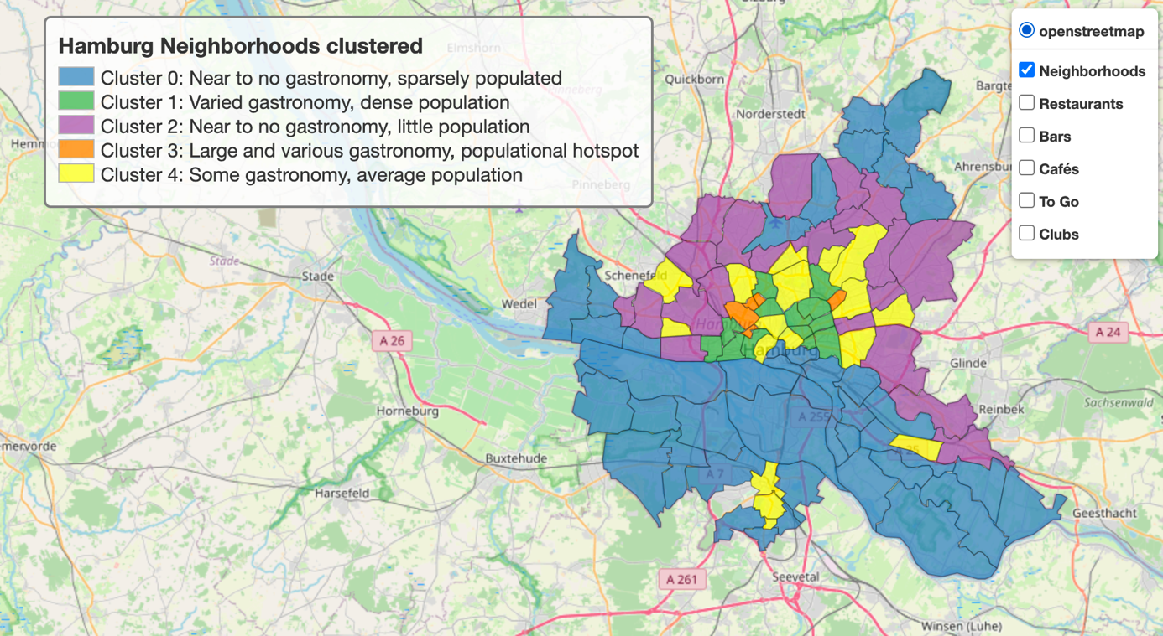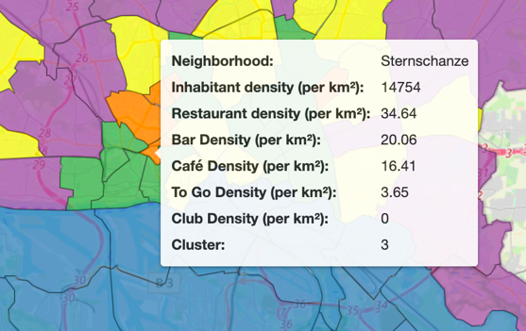

When selecting restaurants to show in the map, the view looks like this. When clicking on one of the points, the establishment name as well as its specific category show in a popup.

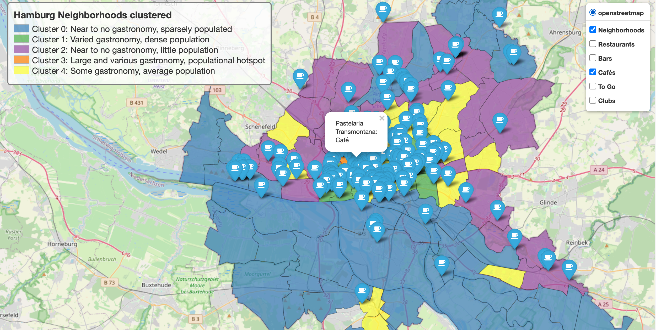

To give this report some personal flavour, I included one of my favourite location of each category; by this, you can see the icon for each category and might discover (really) nice places to go to on your next trip to Hamburg.

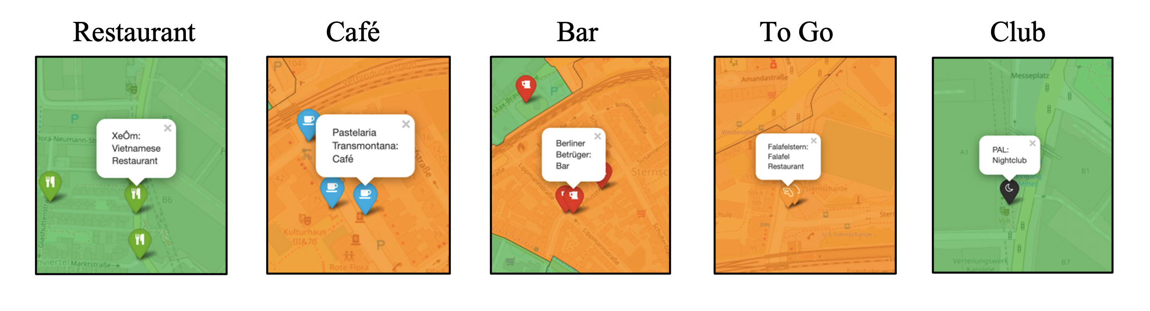

**Discussion**

The results show a largely accurate classification of city districts, based on my experience. The central districts such as Sternschanze, Hoheluft West and Hoheluft Ost indeed show a very high density of restaurants, cafés, bars etc. and are therefore correctly clustered together as gastronomically varied and densely populated. Also the second The outer districts being assinged to Clusters with lower establishment and inhabitant density also appears to be reasonable.  
However, there are some limitations to the presented approach that would have to be refined for commercial use:

1. Probably based on missing information in the Foursquare Database, the map is missing out on a lot of establishments. Some careful observers that have a thorough knowledge of Hamburgs establishments might already tell from the screenshots above, that some well-known and long established locations are missing (for example the Saal 2 or Tier Bar in the middle screenshot). As I noticed that quite a lot of establishments I know are not present in the data, this gives a hint about the insufficiency of Foursquares data for an accurate clustering of city districts.
2. One-Class approach vs. Multi-Class approach: In the analysis at hand, I chose to assign each establishment to one category to simplify the analysis. As you might notice in the screenshot, my favourite To Go establishment is termed “Falafel Restaurant”. This establishment (and all other Falafel restaurants) were labeled as a To Go establishment, although it is sometimes possible to sit down there. This leaves the possibility to assign this establishment to both the category “restaurant” as well as “to go”. However, areas in which many establishments are located might be overrepresented when choosing to count such establishments as both restaurant and to-go; In the analysis, this would count as two localities although being just one. Nontheless, the One-Class approach goes along with ambiguity of classes and therefore leaves room for debates.
3. When closely examining the districts assigned to each cluster, some irregularities become apparent; Dulsberg, a highly populated district with an somewhat average establishment density was assigned to Cluster 3; the gastronomical and populational hotspot cluster. This and other examples give a hint on how features are weighted in the analysis at hand. Population density thereby seems to be way more influential than establishment density. Regarding this, I speculate about a differential outcome with a larger coverage of Foursquare data: In the given analysis, many districts show no single bar, restaurant, café, etc.. As a differentiation in regions with a sparse gastronomy is very difficult (as many districts simply show 0 etablishments of some categories), clustering can be only done in a reliable manner using inhabitant density across all districts. Using more complete gastronomical data might solve this problem too, as a better differentiation in areas with lower gastronomical density becomes possible. The mostly accurate classification of central city districts might further be part of this problem, too: As a high inhabitant density most likely goes along with a high establishment density, the semantically accurate clustering of Sternschanze, Hoheluft West and Hoheluft Ost to the gastronomical and populational hotspot cluster might mostly be based on the high inhabitant density rather than the also high establishment density.

**Conclusion**

Although being subject to some limiations, the approach of district clustering worked quite well and might actually prove valuable when used for tourisitcal city exploration. Using the generated map, tourists would be guided towards the gastronomically most highly frequented and most varied areas and would therefore be satisfied with the maps guidance. By further extending the map with switchable establishment locations, the user is provided with rich information while at the same time not being overwhelmed with popups and map markers. If richer gastronomical data could be provided, a more accurate and more balanced clustering of districts would be possible – unfitting districts in clusters would be less likely. To further refine district clustering, the used features might further be extended: Incorporation of an establishments price level as well as some economical data of districts like rent prices or housing prices could serve as additional features. With such extensions, districts showing a comparable establishment density but highly differential etablishment characterists (e.g., High class restaurants vs. Pizza Stores) might be more accurately clustered.

I very much hope you enjoyed my final project - I had loads of fun doing it!

Best

Max

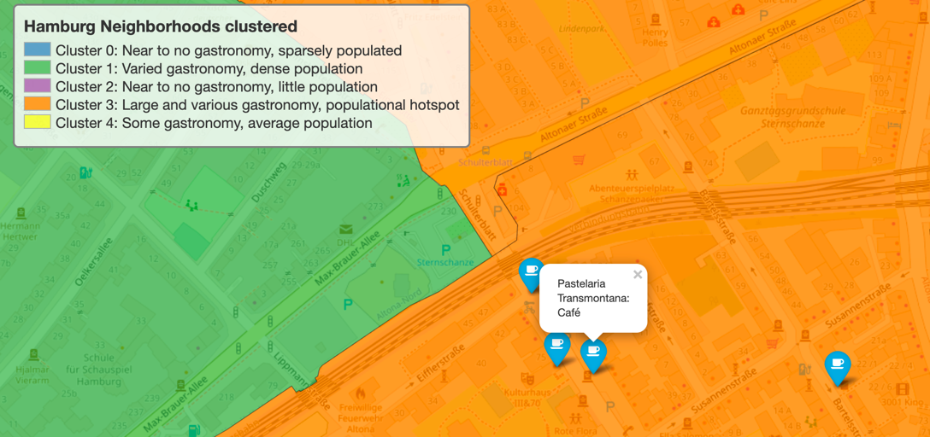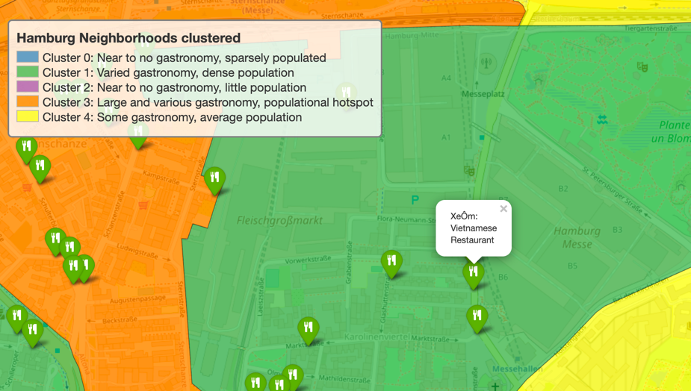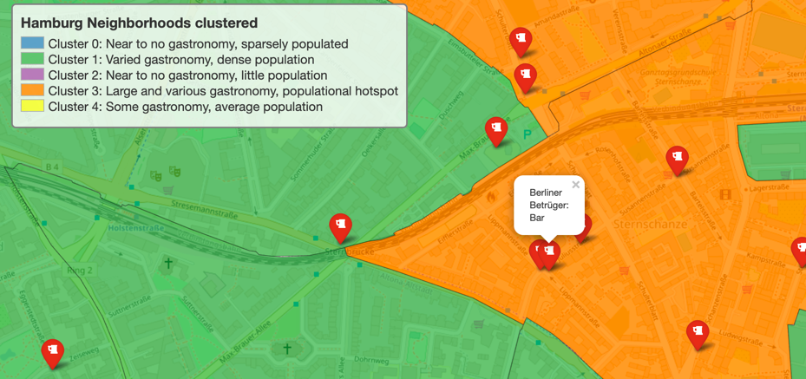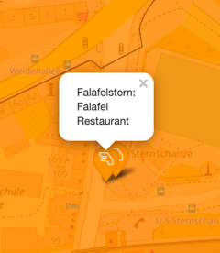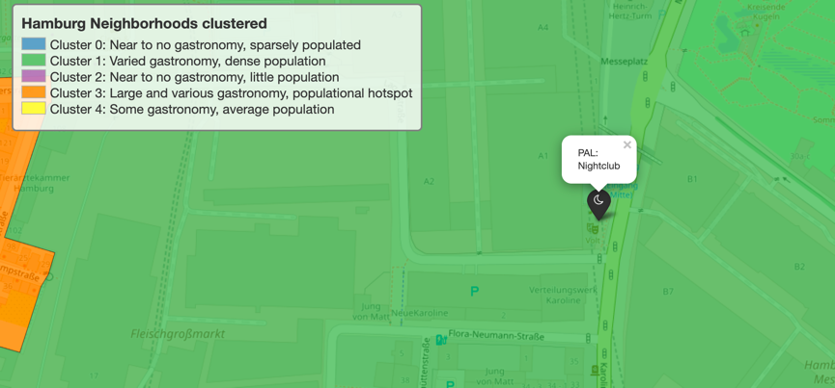

|  |  |  |  |  |
| --- | --- | --- | --- | --- |
| Restaurant | Café | Bar | To Go | Club |